

**Troy Elementary School**

**Sixth Grade Supply List**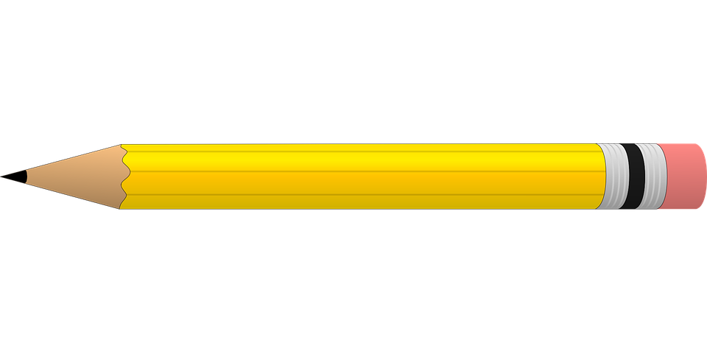

**2025-2026**

| **Required items:**   * Wide-ruled notebook paper * Large or Extra Large book   Bag   * 1- 5 pack **pocket** dividers * Post-it notes * 4-Sewn composition notebooks (**NO Spirals)** * Pencils * Sheet protectors **(ELA)** * Expo Markers **(Math)** * Index cards **(Math)** * Crayons - 24 count **(NO Markers)** * Highlighters * Liquid glue * 3-ring Pencil pouch | **Optional items (Greatly Appreciated):**   * Germ-X * 2- rolls of paper towel * **GIRLS**- 1 box of gallon size Ziploc bags * **BOYS**-1 box of quart size Ziploc bags * Disinfecting wipes * Kleenex * Hand soap * Band-Aids |
| --- | --- |