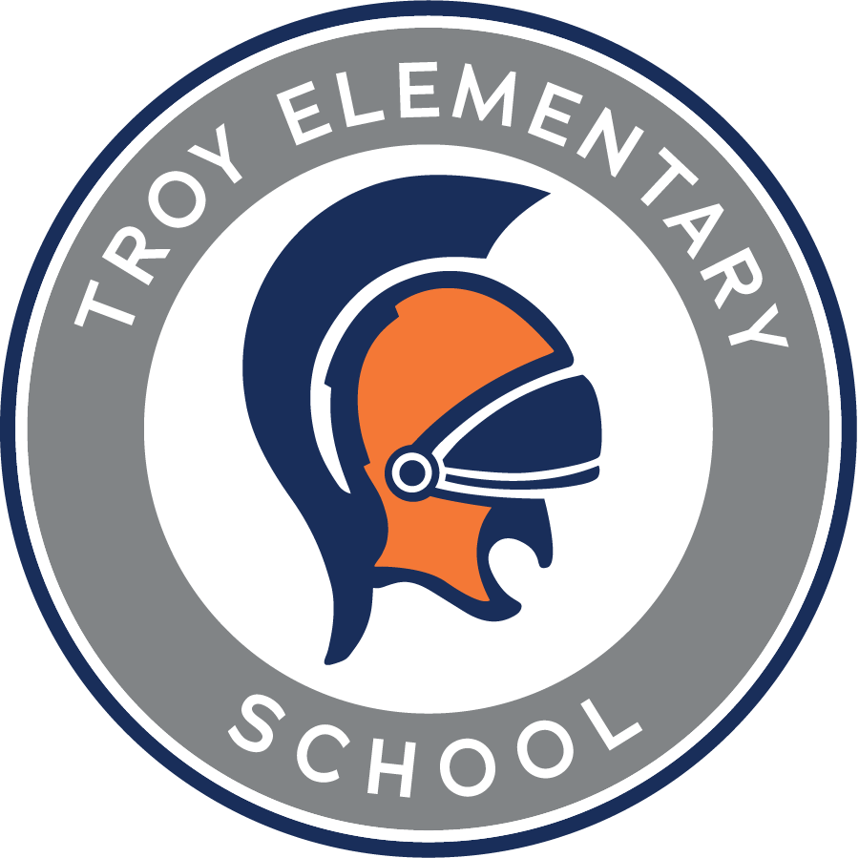

**Troy Elementary School**

**First Grade Supply List**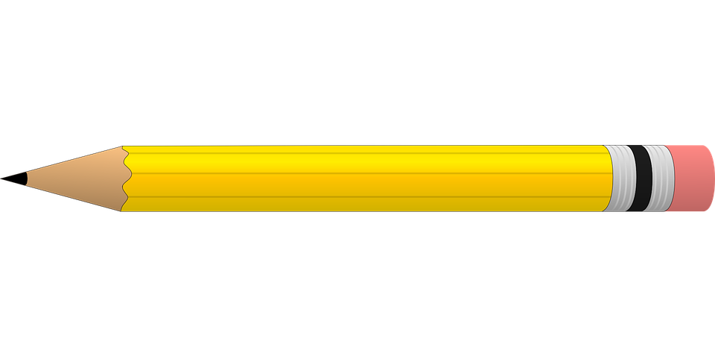

**2025-2026**

| **Required items:**   * Fiskars Scissors * 2 packs of yellow #2 pencils (NO mechanical or decorative) * 10 glue sticks * 3 individual boxes of 24 count crayons * 1 regular plastic supply box (NO fluffy or zipper options) * 2 large pink erasers * 10 skinny black dry erase markers * 1 individual pack of washable markers (for coloring, example: crayola) | **Optional items (Greatly Appreciated):**   * Germ-X * 2- rolls of paper towel * GIRLS- 1 box of gallon size Ziploc bags * BOYS-1 box of quart size Ziploc bags * Disinfecting wipes * Lysol spray * Kleenex * Hand soap * Band-Aids |
| --- | --- |