

**Troy Elementary School**

**Fourth Grade Supply List**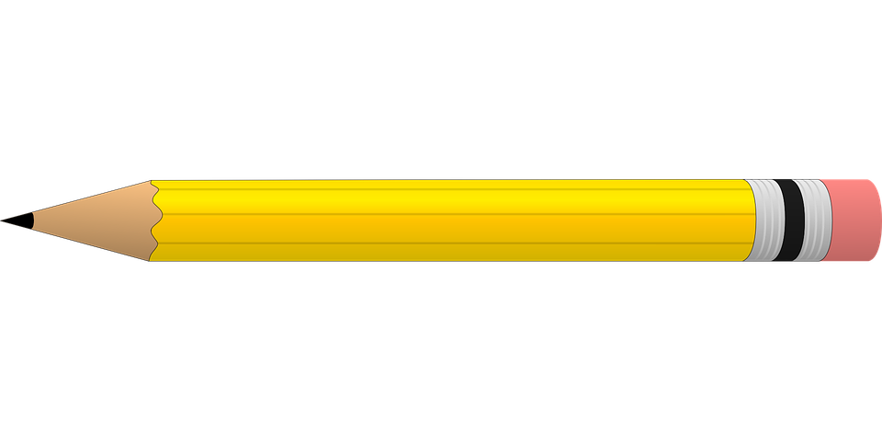

**2024-2025**

| Required supplies:   * 3 heavy duty 3 hole punched plastic folders with pockets * 1 pair of scissors * 2 large glue sticks * 1 box of 24 count crayons * 1 pack of 24 #2 pencils * 1 pack of Expo markers * 1 zipper pencil pouch for binder * 2 packs of sticky notes * 1 pack of index cards * 1 pack of highlighters * 2 packs of wide ruled notebook paper * 2 composition notebooks * 1 pack of copy paper(not cardstock)   **\*\*\*1- two inch binder & 1- 5 pack of pocket dividers will be provided to every student\*\*\*** | Optional items (Greatly Needed):   * Germ-X * 2 rolls of paper towels * Disinfecting wipes * Lysol spray * Kleenex * Hand soap * Band-Aids * **Mouse**(wireless or plug in) Must be chromebook compatible! They will be used DAILY in class   ** Mice help prepare students for ACAP & will have daily use! |
| --- | --- |