

**Troy Elementary School**

**Fifth Grade Supply List**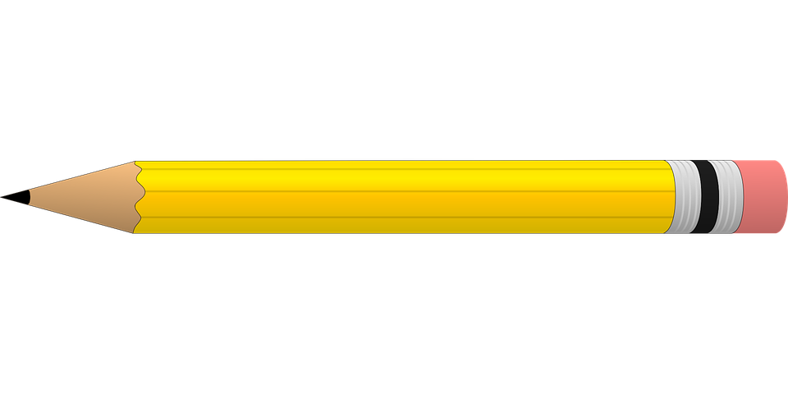

**2025-2026**

| **Required items:**   * 1- 5 pack **Pocket** dividers * 2 packages of #2 pencils * Pack of highlighters * Dry erase markers * Handheld pencil sharpener with a lid * 1 box of crayons * 1 pack of colored pencils * 1 pack of washable markers * 2 packages of wide ruled notebook paper * 3 wide ruled composition notebooks * Zipper close pencil pouch for binder * 2 packs of Notecards or Index Cards | **Optional items (Greatly Appreciated:)**   * Germ-X * 2- rolls of paper towel * Disinfecting wipes * Clorox Wipes * Kleenex * Hand soap * Band-Aids |
| --- | --- |