

**Troy Elementary School**

**Fourth Grade Supply List**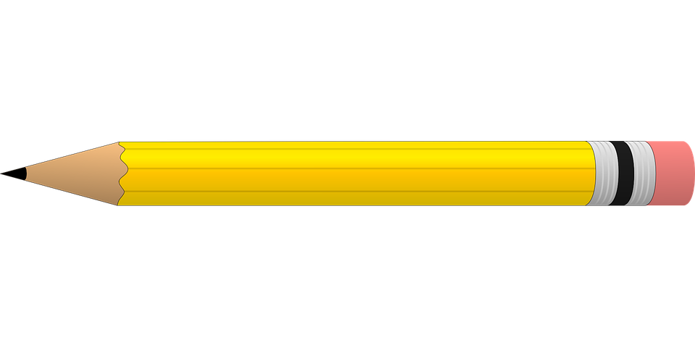

**2025-2026**

| **Required items:**   * 4 heavy duty 3 hole punched plastic folders with pockets * 1 pair of scissors * 2 large glue sticks * 1 box of 24 count crayons * 1 pack of 24 #2 pencils * 1 pack of Expo markers * 1 zipper pencil pouch for binder * 2 packs of sticky notes * 1 pack of index cards * 1 pack of highlighters * 2 packs of wide ruled notebook paper * 2 composition notebooks | **Optional items (Greatly Appreciated):**   * Germ-X * 2 rolls of paper towels * Disinfecting wipes * Lysol spray * Kleenex * Hand soap * Band-Aids |
| --- | --- |